Possible major project- renew library?

* Come up with different floor plans/layout designs for the library
* One with the possibility of custom right triangle shaped bookshelves to fill in the corners by the couch.
* Could have another where we move the printers on the small wall by the couch. (would be good since that’s where the outlet is)
* Move the arcade cabinets by the couch and move the shelves to the piano wall
* Make CSH logo out of wall cube shelves?
* Etc.
* Need to either measure the library or look at the wiki to see if I can find anything there.

10/26/22

Found this interior design website called Cedreo that’s free and will hopefully work for my major project idea.

11/15/22

Brought my library idea up to Olivia and she thought it sounded cool :)

3/13/23

Started to try and get measurements of everything in the library. Not entirely confident in my final measurements because each time I measured something I seemed to get a different result.

Update: Forgot to measure the conduit on the walls in terms of how far it is from the ceiling.

Update #2: So I didn’t measure the height of anything LOL

3/14/23

Took some additional measurements as I forgot to take measurements for positioning and height for the window, ac, ac conduit, and wall conduit.

Update: Starting working in Cedreo to create the base layout for the library and start adding things inside.

Update #2: I don’t think Cedreo is going to work out :( When trying to actually make the inside portion of the library I couldn’t really find what I wanted and there was no way to really measure where to place things.

3/17/23

I found a new design website called Neo Foyr and got a free trial for it. Hopefully this has everything I need.

Update: Started getting the base of the room down and it’s going much better.

Update #2: I forgot to measure where the outlets were on the couch wall. Will have to go back and do that later.

3/18/23

Progress I’ve made!

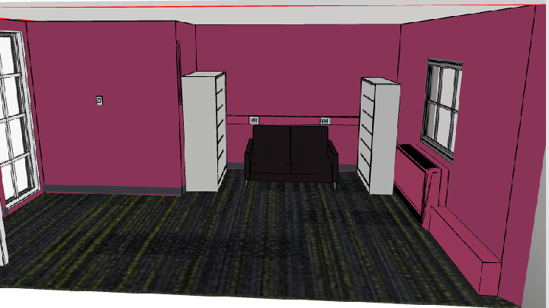

3/23/23

Retook measurements for couch and measured where the outlets started on the couch wall. Also reverified measurements for the shelves and where the electrical conduit was on the wall.

3/28/23

Got word from Avan about the arcade cabinets. Housing said no to moving them out :( so that means I'll have to scrap the designs that involved moving the cabinets.

3/30/23

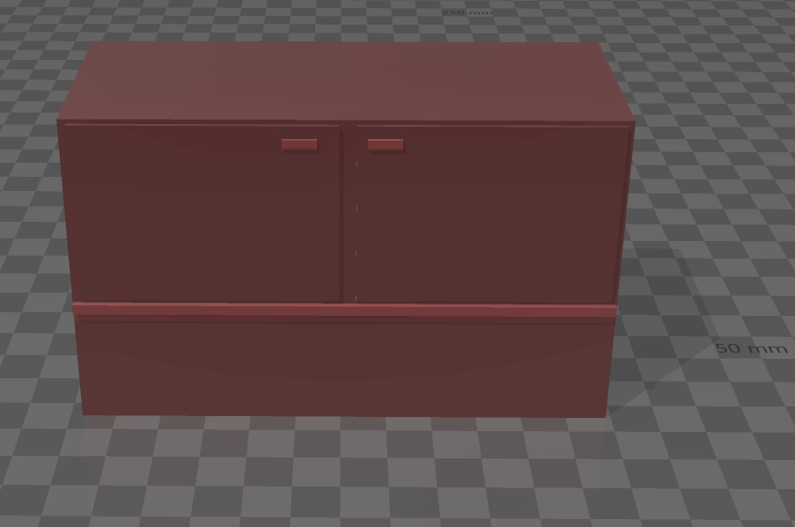Making a rough version of the metal cabinet the printers are sitting on to upload to Foyr Neo.

Making a little router to upload

Made quite a bit of progress! All I have left to do is to finish the printer wall and then I will be done with getting the layout of the library as it currently is.

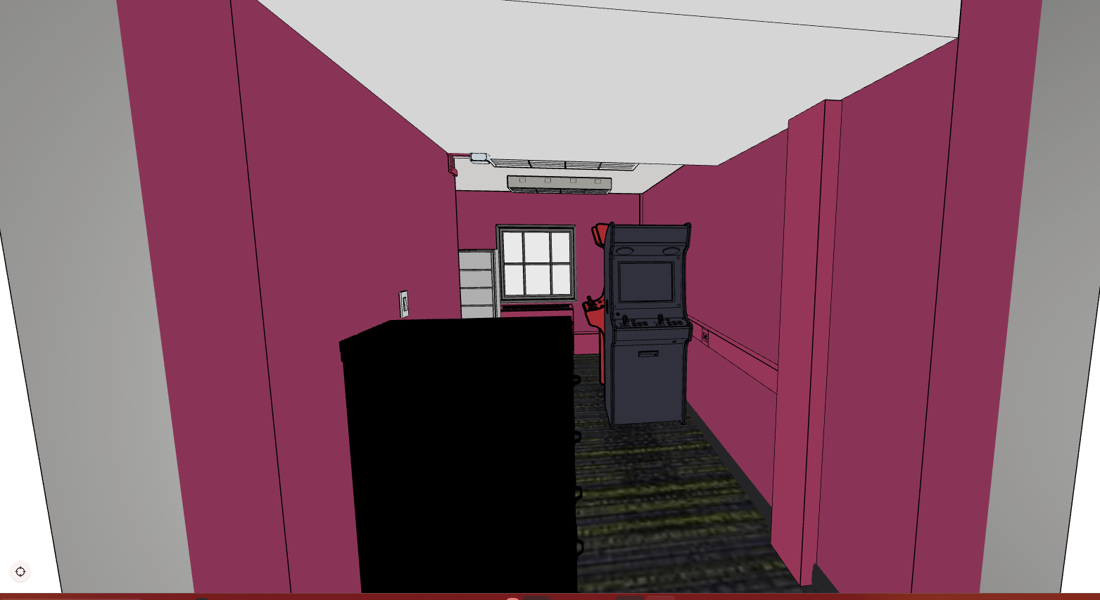

4/1/23

Finishing up the layout as it is now.

4/3/23

4/4/23

Layout #1- Moving the arcade cabinets to be on either side of the piano

Pros:

* Easiest thing to do (would take very little to actually do)
* Makes it look a little better.

Cons:

* Doesn’t really do much in terms of maximizing space and doesn’t really solve any problems

Layout #2- This one builds upon the last layout and adds in custom CSH shelving!

Pros:

* Builds upon the last one and adds cool custom CSH shelving! We could even possibly add lights to it and make it look even cooler!

Cons:

* Making the custom shelves might be somewhat difficult.
* We’d also have to probably get housing to approve this since they’d be mounted to the wall. Maybe it would be more persuasive if we let them install it?

Making NFC Icon

Layout #3- Adds upon the previous layout and moves the printers to the wall by the couch

* + “The Flex Space” is an area that is dedicated to different pictures or articles that we can put up. The idea is to have different things we can swap out for different events like have something we specifically put up for tours etc.
    - But also lowkey having a sign like that there would be kinda cool

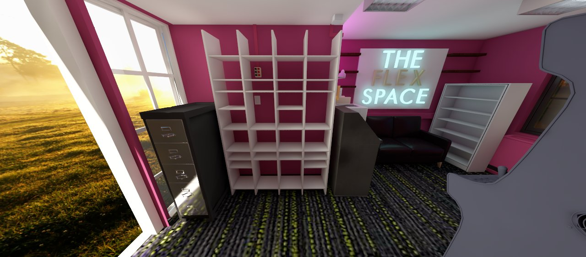

Pros:

* Moves all the electrical equipment closer to the outlet
* Moves the printers out of the walkway and you can print while sitting on the couch!
* More shelves!!
* Replaces the crappy metal shelf that’s currently by the couch
* Possibly add cute little signs?

Cons:

* Would take a lot of moving around
* A new cool shelf unit might cost some money
* Like the previous one, would have to get approval to add wall shelves

Layout #4 – Drink Admin redesign

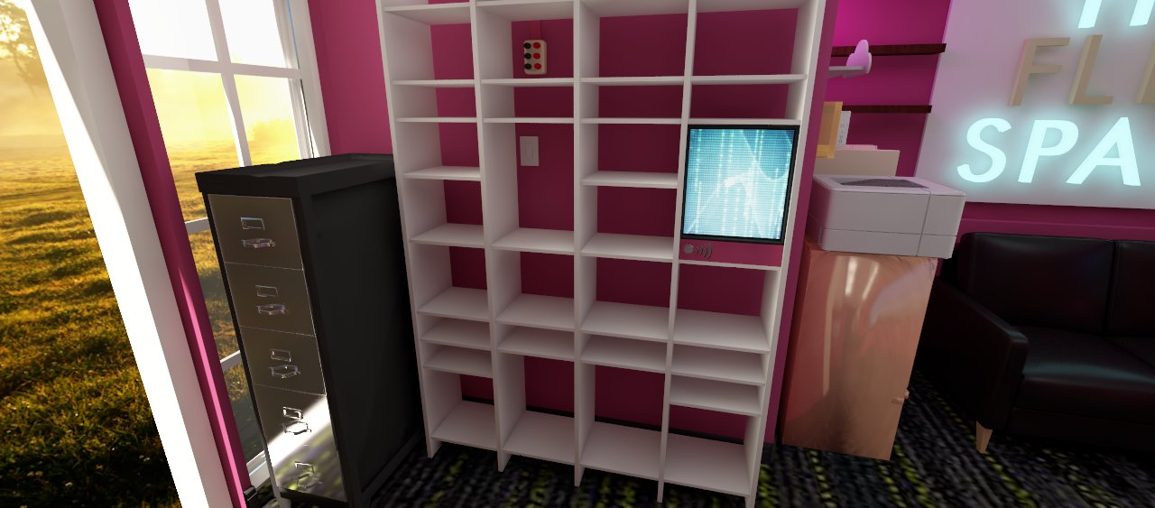

Pros:

* Gets rid of the current clunky drink admin

Cons:

* Someone would have to figure out how to make the new one and get it to work